CS 306 Project Phase 2

Ufuk Ulaş Tokat 28914

I chose product and inventory tables from our code.

**I inserted also in category table because there was a constraint for it in our code.**

CREATE TABLE category (

id INT PRIMARY KEY AUTO_INCREMENT,

`name` VARCHAR(40) NOT NULL UNIQUE

) AUTO_INCREMENT=1;

**INSERT INTO category (`name`)**

**VALUES**

**('Electronics'),**

**('Clothing'),**

**('Furniture'),**

**('Books'),**

**('Toys'),**

**('Sports'),**

**('Appliances'),**

**('Jewelry'),**

**('Beauty'),**

**('Food');**

-- ------------------------------------------------------------------ --

CREATE TABLE product (

id INT NOT NULL PRIMARY KEY auto_increment,

`name` VARCHAR(100) NOT NULL,

category_id INT NOT NULL,

price DECIMAL(10,2) NOT NULL,

weight DOUBLE NOT NULL,

`active` BOOL NOT NULL,

`description` TEXT,

created DATETIME NOT NULL DEFAULT current_timestamp(),

CONSTRAINT priceCheck CHECK (price > 0),

CONSTRAINT weightCheck CHECK (weight > 0),

CONSTRAINT FK_category_id FOREIGN KEY (category_id) REFERENCES category(id) ON DELETE NO ACTION ON UPDATE CASCADE

) AUTO_INCREMENT=1;

**INSERT INTO product (`name`, category_id, price, weight, `active`, `description`)**

**VALUES**

**('Laptop', 1, 899.99, 2.5, 1, 'High-performance laptop with a powerful processor.'),**

**('Smartphone', 2, 699.99, 0.2, 1, 'Flagship smartphone with a stunning display.'),**

**('Coffee Maker', 3, 49.99, 1.5, 1, 'Programmable coffee maker for your morning brew.'),**

**('Headphones', 4, 149.99, 0.3, 1, 'Wireless over-ear headphones with noise cancellation.'),**

**('TV', 1, 999.99, 25.0, 1, '55-inch 4K Smart TV for your home entertainment.'),**

**('Tablet', 2, 299.99, 0.5, 1, '10-inch tablet with a high-resolution screen.'),**

**('Blender', 3, 39.99, 2.0, 1, 'Powerful blender for making smoothies and more.'),**

**('Wireless Speaker', 4, 79.99, 0.5, 1, 'Portable wireless speaker with excellent sound quality.'),**

**('Microwave Oven', 5, 79.99, 1.0, 1, 'Countertop microwave for quick cooking.'),**

**('Toaster', 6, 29.99, 1.0, 1, '2-slice toaster for perfect morning toast.');**

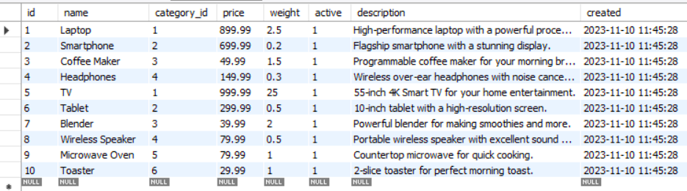

-- ------------------------------------------------------------------ --

CREATE TABLE inventory (

product_id INT NOT NULL,

quantity INT NOT NULL,

last_updated DATETIME DEFAULT NULL ON UPDATE CURRENT_TIMESTAMP(),

-- last_updated_by INT, -- backend'den bağla, sessiondan loginli employeenin id sini kullanıp bu rowun bu column'u nu UPDATE et

-- asıl işlem sonrası...

CONSTRAINT FK_product_id FOREIGN KEY (product_id) REFERENCES product(id),

CONSTRAINT quantityCheck CHECK (quantity > -1)

);

**INSERT INTO inventory (product_id, quantity)**

**VALUES**

**(1, 10),**

**(2, 15),**

**(3, 20),**

**(4, 5),**

**(5, 20),**

**(6, 12),**

**(7, 10),**

**(8, 7),**

**(9, 7),**

**(10, 18);**

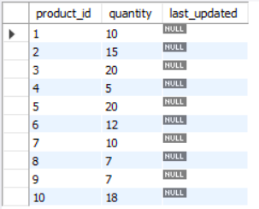

-- ------------------------------------------------------------------ --

**Query 1**

**Names of products whose quantity is more than 15 in inventory.**

**SELECT name FROM product p JOIN inventory i ON (p.id = i.product_id) WHERE quantity > 15;**

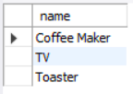

**Query 2**

**Category ids which are bigger than 4 and quantity of those products which has max quantity at their categories.**

**SELECT category_id, max(quantity) FROM product p JOIN inventory i ON (p.id = i.product_id) GROUP BY category_id HAVING category_id>3;**

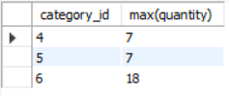

**Alter**

**ALTER TABLE inventory ADD CONSTRAINT CHECK (10 <= (SELECT quantity**

**FROM product p JOIN inventory i ON (p.id = i.product_id)**

**WHERE weight > 2.5));**